Name: - GAURAV BATRA

Course: - B.Sc. (H) Computer Science Roll No.: - 20221463

Practical Networking: -

Q2. To study and perform PC to PC communication.

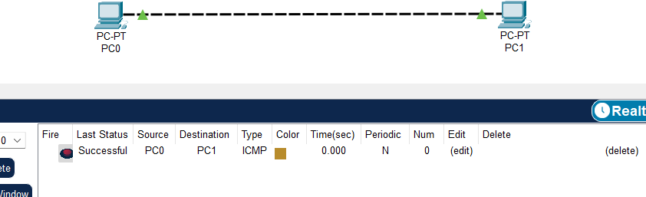

Q3. To create Star topology using Hub and Switch.

1. Using Switch

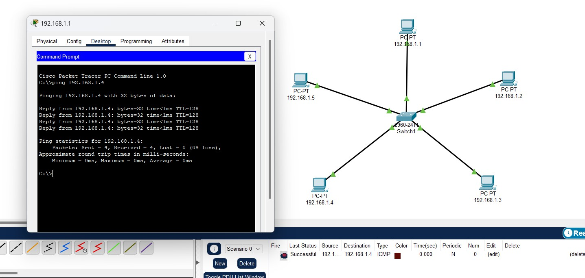

1. using Hub

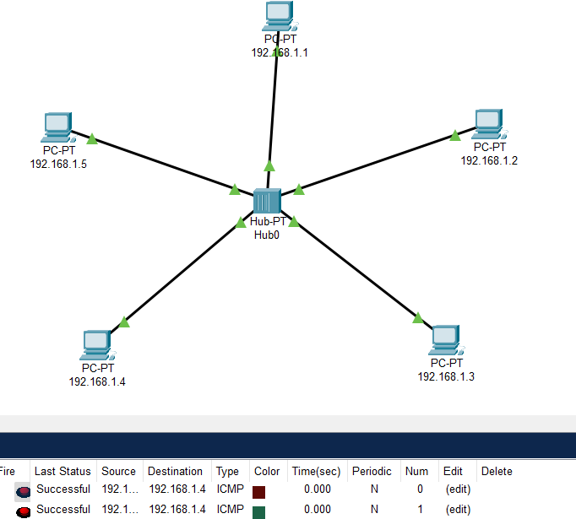

Q4. To create Bus, Ring, Tree, Hybrid, Mash topologies.

1. Bus Topology

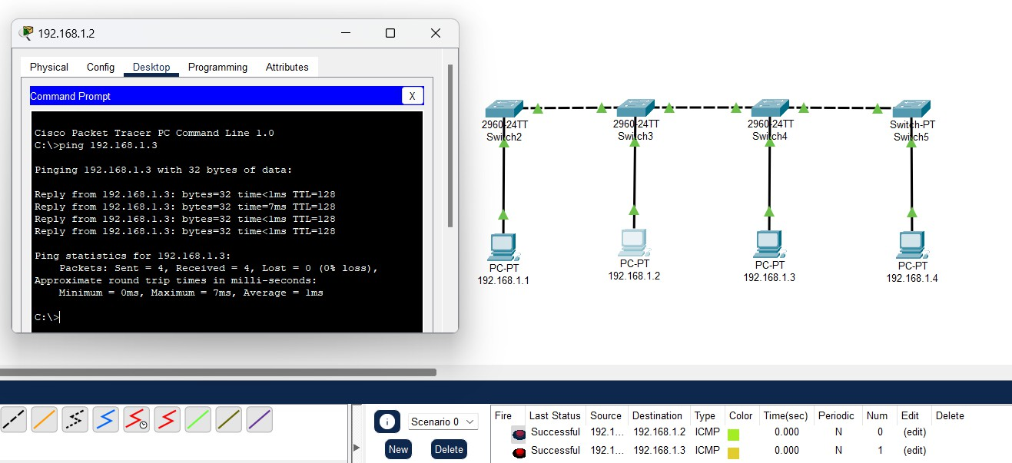

1. Tree Topology

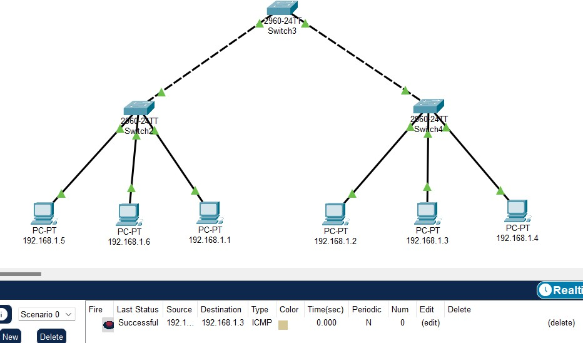

1. Hybrid Topology

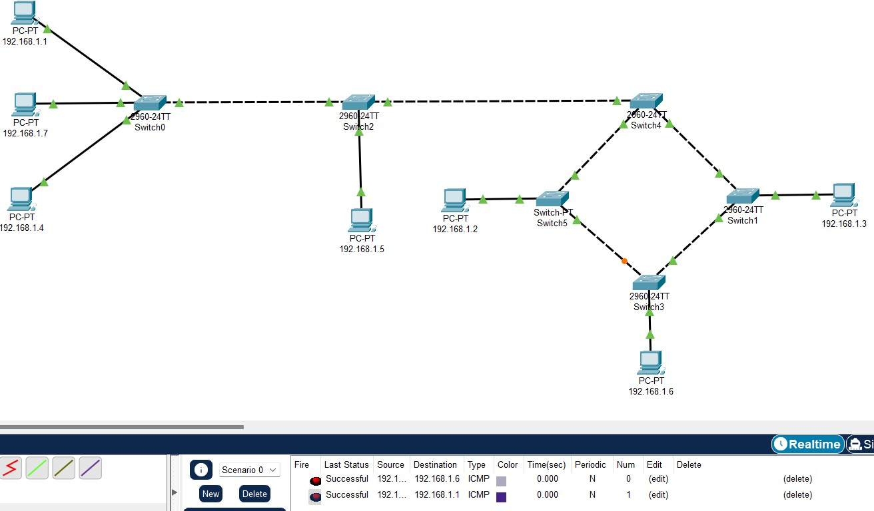

1. Mash Topology

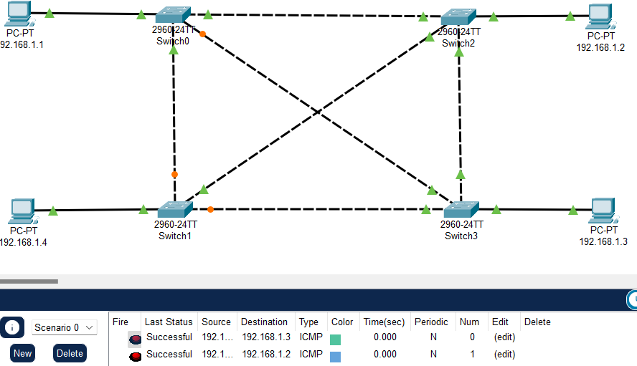

Q5. Perform an initial Switch configuration.

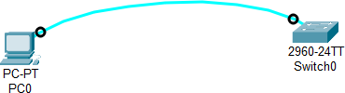

➔ Name

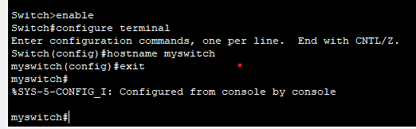

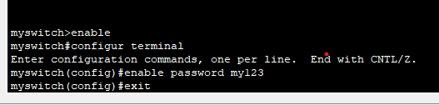➔ password

Q6. Perform an initial Router configuration.

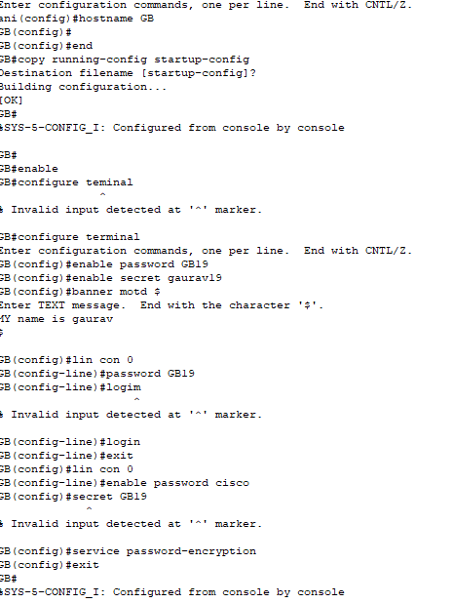

Q7. To implement Client-server Network.

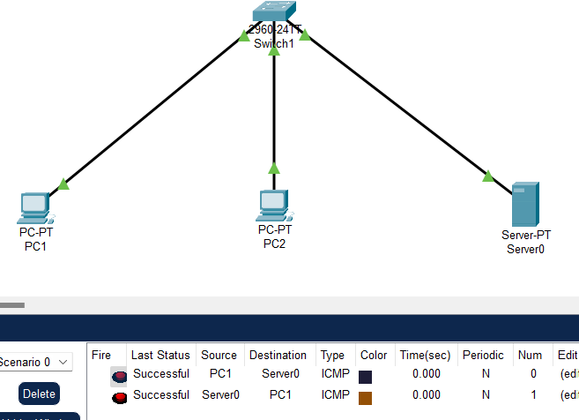

➔ Step 1. In any pc go to web server.

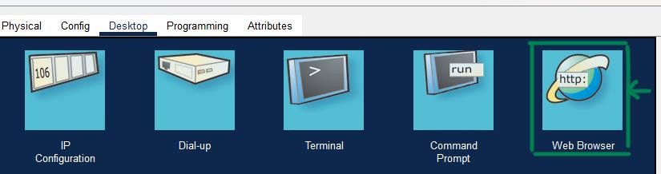

-> Step 2. Enter IP address of server connected to your switch in web server URL. Then press GO.

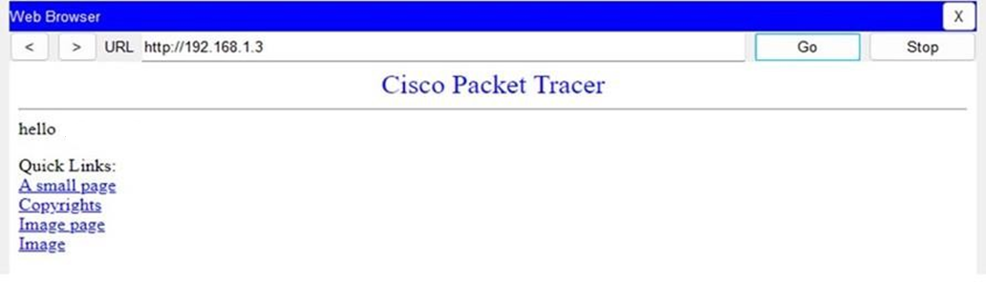

Q8. To implement connection between devices using router.

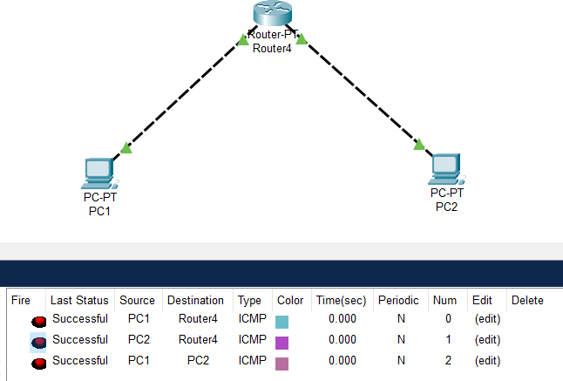

➔ Router Config

